Test Case: tc001_SPX_Dev5_Crear_Requisicion_Spot_Tipo_Cobro_CC
Step 1 - Enter username and password and click to button Enter : Credentials Entered
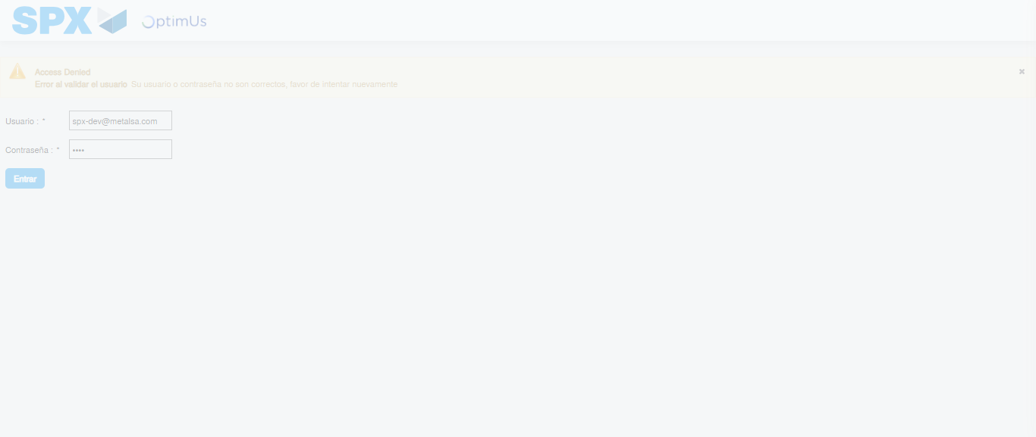Image file-name: QC_Testing-tc001_SPX_Dev5_Crear_Requisicion_Spot_Tipo_Cobro_CC-1783980606457

Step 2 - Select to UEN and Access to Spot Buy Requisitions : UEN Correctly selected and Correct access
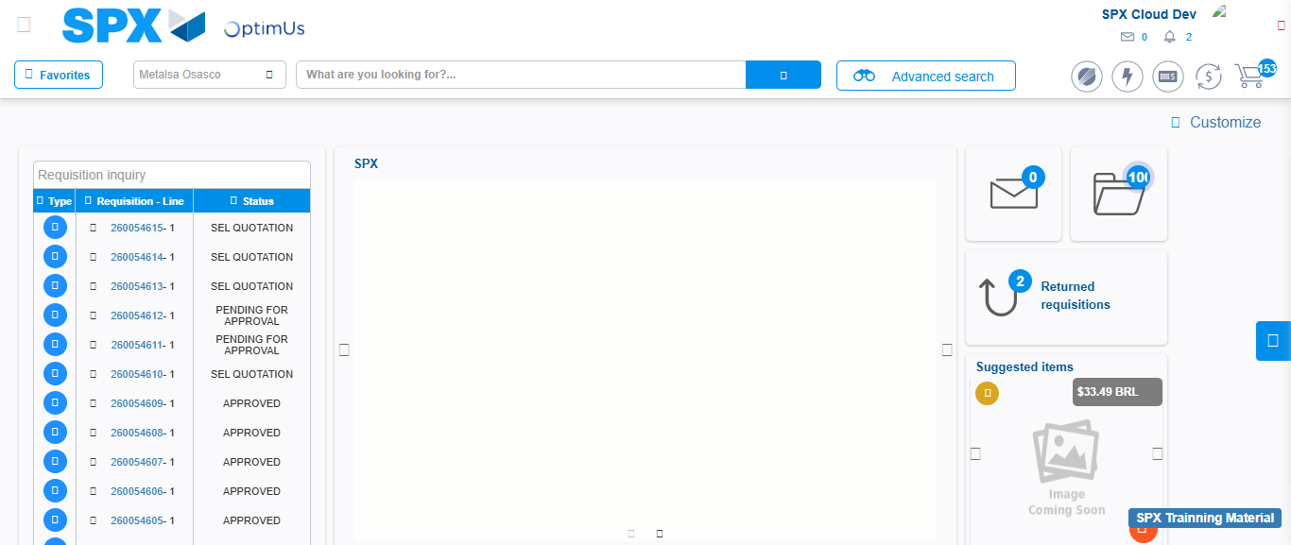Image file-name: QC_Testing-tc001_SPX_Dev5_Crear_Requisicion_Spot_Tipo_Cobro_CC-1783980654395

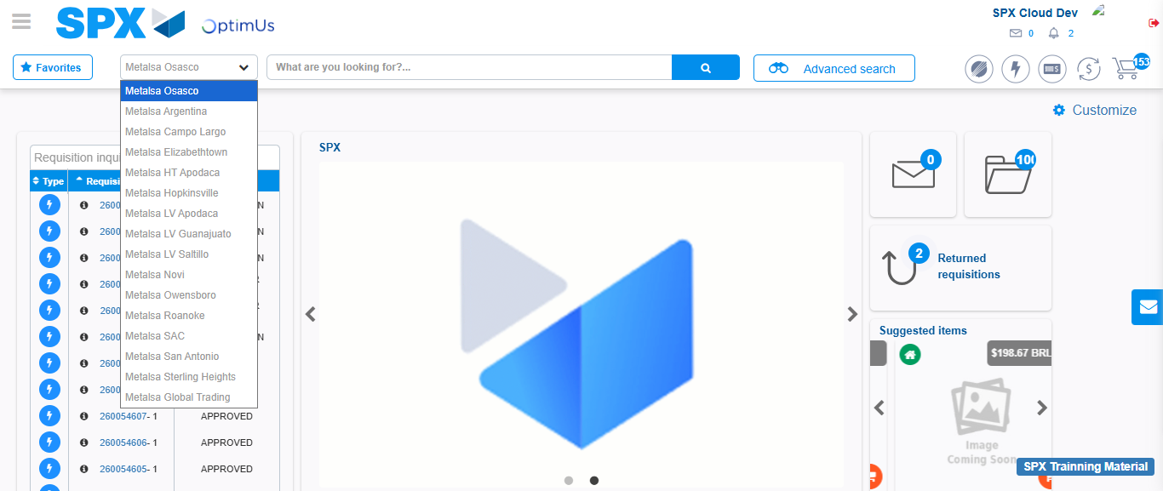Image file-name: QC_Testing-tc001_SPX_Dev5_Crear_Requisicion_Spot_Tipo_Cobro_CC-1783980656988

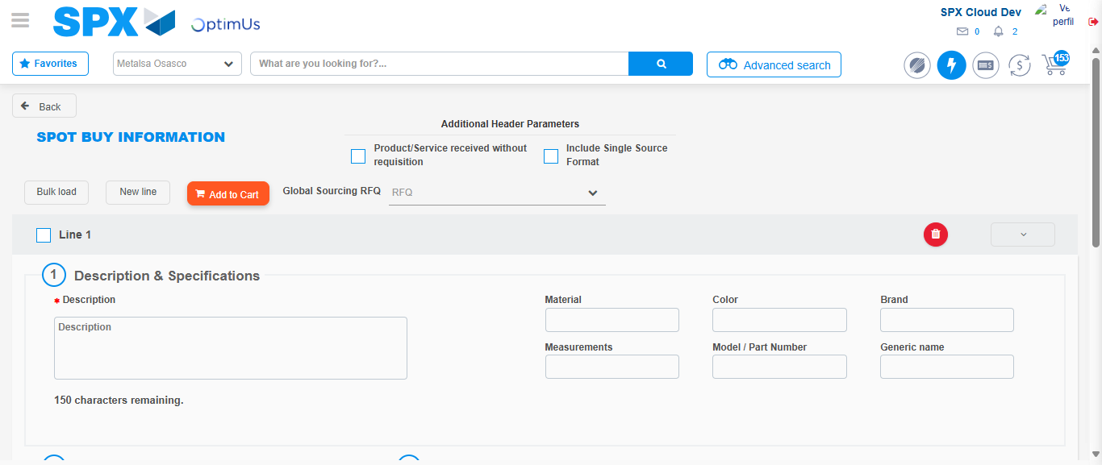Image file-name: QC_Testing-tc001_SPX_Dev5_Crear_Requisicion_Spot_Tipo_Cobro_CC-1783980665440

Step 3 - Data Capture Spot Buy Requisition : Data captured correctly
Image file-name: QC_Testing-tc001_SPX_Dev5_Crear_Requisicion_Spot_Tipo_Cobro_CC-1783980665658

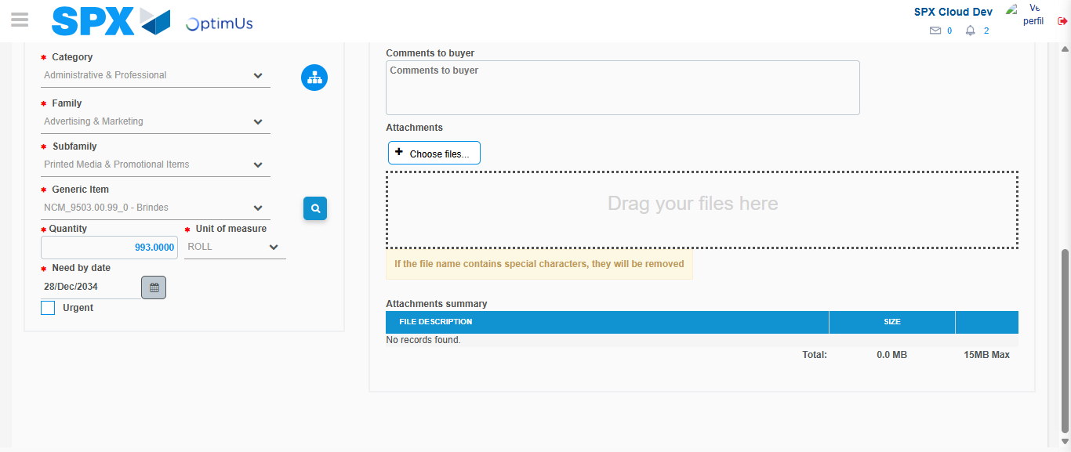Image file-name: QC_Testing-tc001_SPX_Dev5_Crear_Requisicion_Spot_Tipo_Cobro_CC-1783980676731

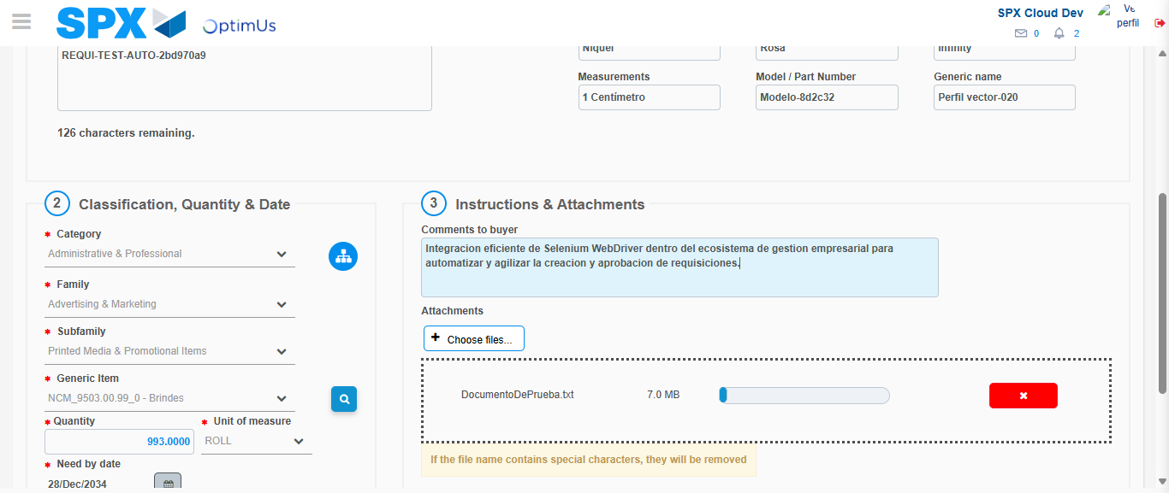Image file-name: QC_Testing-tc001_SPX_Dev5_Crear_Requisicion_Spot_Tipo_Cobro_CC-1783980677434

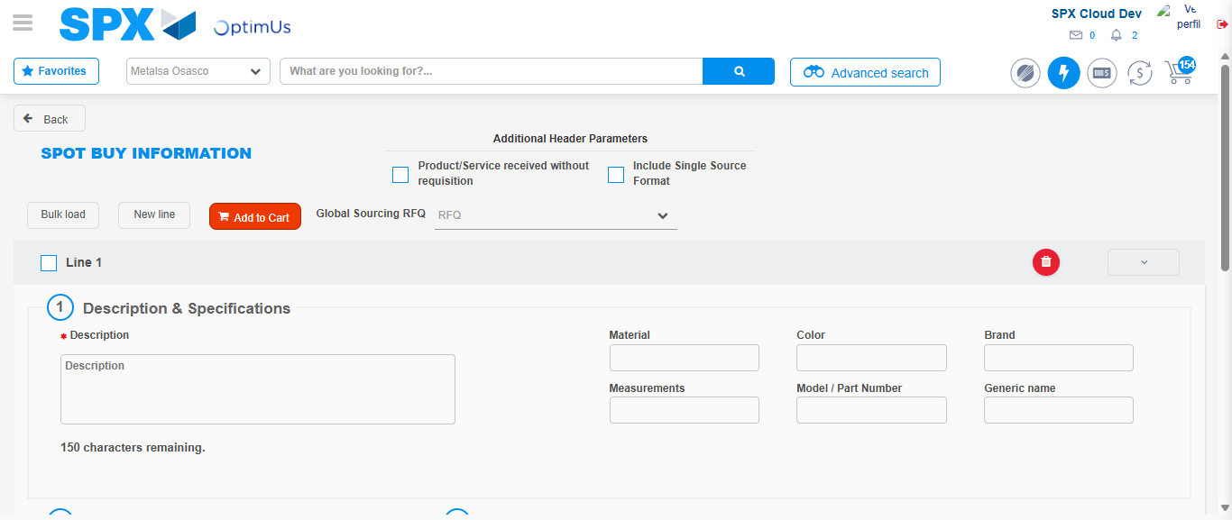Image file-name: QC_Testing-tc001_SPX_Dev5_Crear_Requisicion_Spot_Tipo_Cobro_CC-1783980684265

Step 7 - Return to Main Page SPX : Return to Main Page SPX
Image file-name: QC_Testing-tc001_SPX_Dev5_Crear_Requisicion_Spot_Tipo_Cobro_CC-1783980654395

Image file-name: QC_Testing-tc001_SPX_Dev5_Crear_Requisicion_Spot_Tipo_Cobro_CC-1783980656988

Image file-name: QC_Testing-tc001_SPX_Dev5_Crear_Requisicion_Spot_Tipo_Cobro_CC-1783980665440

Image file-name: QC_Testing-tc001_SPX_Dev5_Crear_Requisicion_Spot_Tipo_Cobro_CC-1783980686491

Image file-name: QC_Testing-tc001_SPX_Dev5_Crear_Requisicion_Spot_Tipo_Cobro_CC-1783980686653

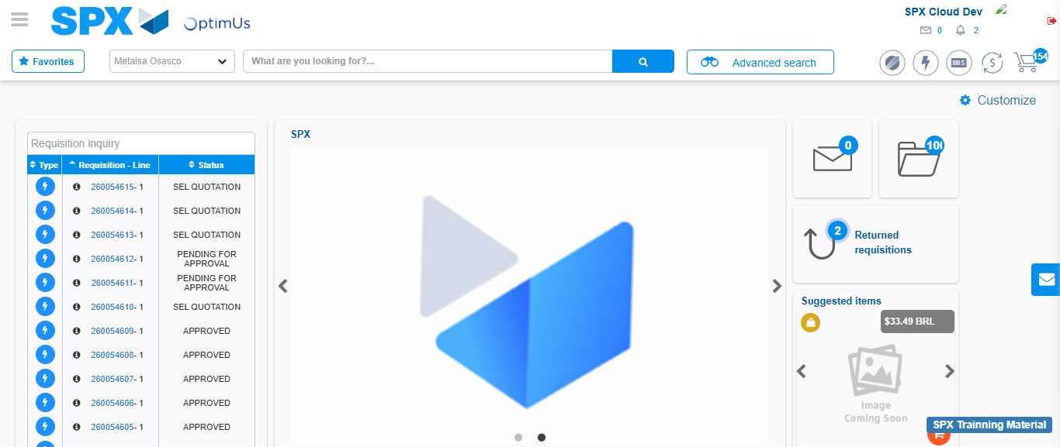Image file-name: QC_Testing-tc001_SPX_Dev5_Crear_Requisicion_Spot_Tipo_Cobro_CC-1783980707641

Step 8 - Log Out : Log Out SPX
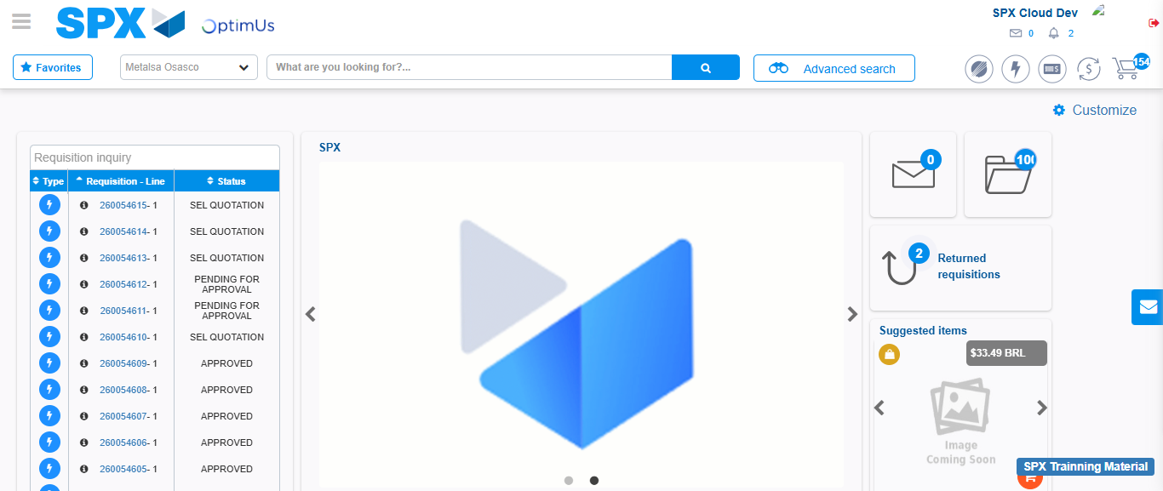Image file-name: QC_Testing-tc001_SPX_Dev5_Crear_Requisicion_Spot_Tipo_Cobro_CC-1783980707933

